

ECONOMICS OF HEALTHCARE

TASK 2



**TABLE OF CONTENTS:**

**Charts and conclusions 2**

**Three detailed interviews 5**

Worker 5

Pharmacists8

Patient11

**One system/practice/condition14**

**Network Map22**

**Team23**

CHARTS AND CONCLUSIONS:

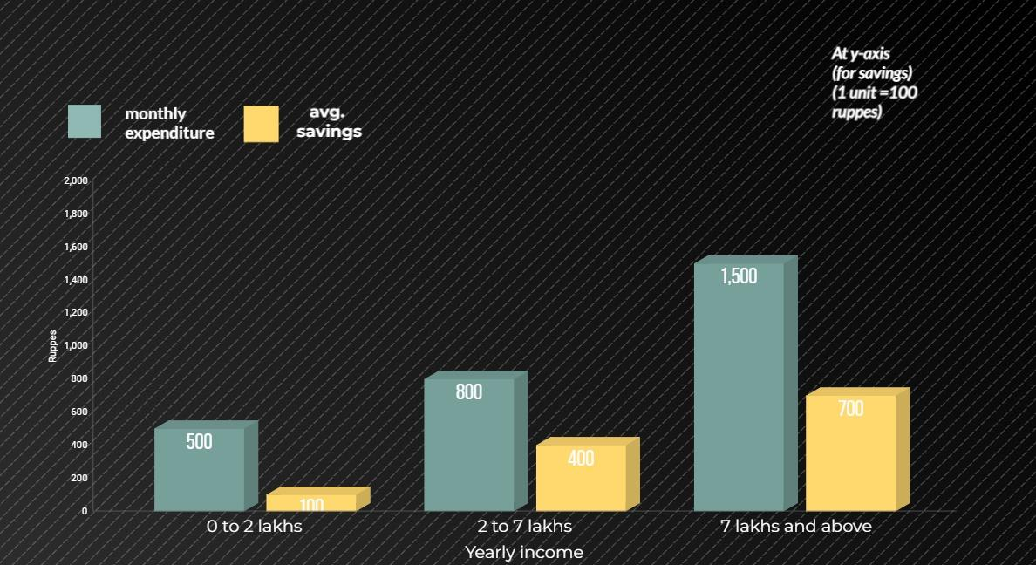

This graph is about the relation between the monthly expenditure and average savings of respondents in context of the annual income of their family.

* By observing the nature of graph, it can be seen that as the annual income increases, the respondents tend to spend more on health care; so, their monthly expenditure also increases. As they spend more, they prefer to visit private doctors with better facilities.
* Therefore, they have more savings for medical emergencies.

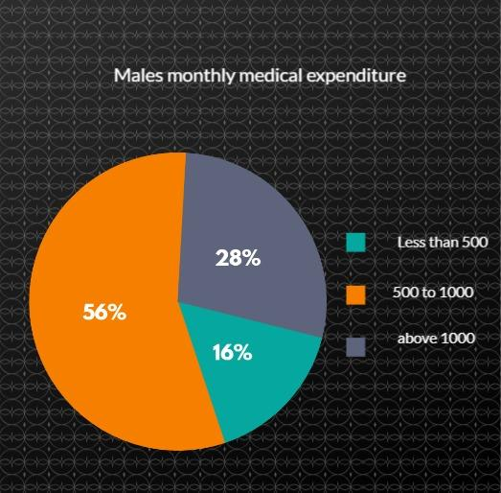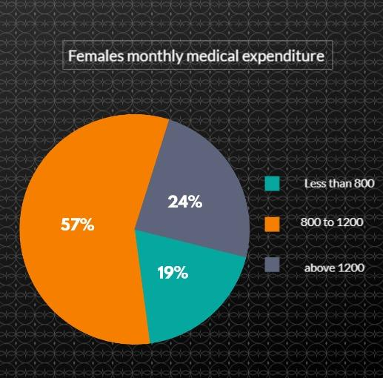

First graph shows the monthly expenditure for males and second for females.

* By observing, we can conclude that majority people (males) had an average monthly expenditure between 500-1000 INR which constitutes 56% of total males; whereas for females, average monthly expenditure ranges between 800-1200 INR which covers 57% of total females.
* It clearly states that majority of female’s average expenditure is more that majority of male’s average expenditure.

This concludes that average expenditure increases for females because of spending on menstrual process (purchasing pads, pills, etc.).



This graph depicts how much percentage of people are aware of government healthcare schemes, and who had enrolled in it or not.

* By observing, 25% of total people were not aware of health care schemes.
* 75% people were aware of health care schemes, out of which, only 48% have enrolled in the schemes.
* This shows that there’s still a scope of bringing in a more inclusive policy by government which benefits everyone especially students.

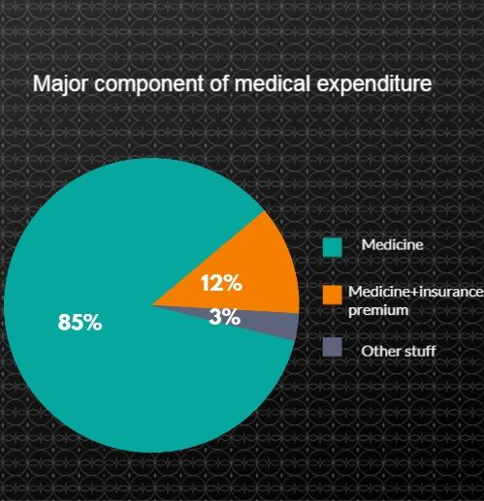

This graph depicts the major contribution of medical expenditure for the respondents; divided in medicines, medicines + premiums and others.

* 85% of the respondents have medicines as the sole component of average monthly expenditure and most of them are found to be students, while the working class also had premiums of their policies and monthly checkups as their monthly expenditure.
* The checkups are due to some age related diseases like blood pressure, diabetes, etc.

General conclusions:

* People with less income generally visit on-campus doctor while people with more income are more likely to visit off-campus doctor.

Although, most of the respondents agreed to the fact of inconvenient timings and less scope of treatment of on-campus medical facilities ; but also people with less income are more likely to compare cost of healthcare of different institutions. Thus, because of economical facilities, they visit on-campus.

* Few students were not aware of their enrollment in any of the schemes/ insurances; but the fact is that all of the students are enrolled in RGI (Reliance Group Insurance) provided by the college. This concludes that there needs to be more awareness regarding schemes.
* Those who preferred generic medicines/ government schemes and on-campus facilities were more likely to have less monthly expenditure

INTERVIEW OF WORKER

The person being interviewed is a worker at Honey one food court.

Aditya: Tell us about yourself and your current job.

Worker: My name is Bhagavad Prajapati and currently I'm working at 'Honey One Food Court' located in DAIICT.

Aditya: Have you or your family ever faced any health-related issues? If so, could you describe your experience?

Worker: Me or my family never experienced severe health-related issues. Only normal fever and cold-like disease were there.

Aditya: Have you ever faced any financial challenges due to unexpected bills or healthcare costs? Can you share an example?

Worker: I never faced such a financial challenge but, in 2015 my daughter was admitted to a civil hospital. Since it is a public hospital there were only some nominal treatment charges.

Aditya: How do you manage healthcare costs within your budget?

Worker: I never faced any severe health issues or healthcare costs so, there was no need to manage healthcare costs in my budget. Also, I don't save money for any health-related emergency due to this history.

Aditya: Do you have any health insurance? If yes, then How has health insurance affected your family's financial condition?

Worker: As I mentioned earlier my family never had to face any financial difficulty due to healthcare. So, I never thought about any health insurance.

Aditya: Are you aware of any government healthcare program or scheme? And have you enrolled in any? If yes, then How has this healthcare program affected you in accessing the necessary treatments?

Worker: Yes, I know some government schemes like 'Mukhyamanti Amrutum Yojana' (MA-card), 'Ayushman Bharat Yojana' (Ayushman-card) etc. But, due to my negligence, I have never enrolled in any of those. But currently, I'm thinking that I should enroll in any of those.

Aditya: How do healthcare expenses impact your overall household budget, and have you noticed any changes in recent years?

Worker: Healthcare expenses never disturbed my overall budget because as I said I never had to face any severe health difficulty. There are hardly 1,000/- health costs in a month. In reality, I never need to visit a hospital or clinic so often. Therefore, I have no certain idea about changes in healthcare expenses in recent times.

Aditya: Are you aware of generic and branded medicines? If yes, then share your thoughts about it.

Worker: I don't know what's the difference between them but, whenever I have to buy any medicine first I go to the nearby 'Jan Aushadhi Kendra' run by the government and there is a significantly lower price of medicines than the market. If I can't find medicine then only i prefer any other store. (Then we explained to him what's the difference)

Aditya: When a doctor prescribes you some medicines have you ever asked about whether it is generic or branded?

Worker: I never asked the doctor about it but, I don't buy medicines from stores as advised by the doctor. Instead, first, I prefer the nearest Jan Aushadhi Kendra so I can save some money.

Aditya: Suppose that your health condition is severe, then which hospital would you prefer, a government hospital or a private hospital?

Worker: I would prefer a government hospital, the reason is not the low cost, but the treatment we get is from a basic level. It takes time at the government hospitals for the treatment but the treatment is proper. People go to private hospitals as they get the facility there. But the people's treatment is the same in the government and the private sector. The private hospitals charge a high fee for the facilities they provide.

Aditya: Do you visit the on-campus doctor?

Worker: I haven't needed to visit there yet, but I visit there along with my colleagues if they are ill, and they are good too.

Aditya: Do you get any healthcare benefits from the place you work at?

Worker: No, as we work on the contract base and we are not at all permanent here and we are not in the staff of that place. So, these things do not apply to us, but I am free to visit the on-campus doctor.

Aditya: According to you, what improvements/changes can be made to the current healthcare system that benefits all?

Worker: Almost all the medicines given by the government are free, we just need to register and pay 5 rupees which is a very nominal fee, it is okay if they increase it to 10 or 20 rupees which is not a very big cost. The medicines and the treatment we receive are comparatively very good. Also, other treatments like surgery and operation, X-rays have a very nominal fee in civil hospitals. But if they do it systematically, then it is good the queue at the hospital billing area is very long and it is very time-consuming, and that's bound to happen because all the public is coming there.

INTERVIEW OF PHARMACIST

The person being interviewed is a pharmacist at Radhe pharmacy near DA-IICT. The choice of him as an expert is because the biggest proportion of the medical expenses of respondents is of medicine and drugs.

Herik: Basic background like name, qualification & how long you have been running this pharmacy?

Chirag: My name is Chirag Gopaldas Gandhi, Radhe medical provision store, diploma pharmacy and working for 23 years in this field

Herik: Can you give us a rough idea of the types of medicines you keep in stock, including commonly used ones like paracetamol?

Chirag: Almost every allopathic medicine, paracetamol, amoxicillin, etc

Herik: Has it covered all type of general medicines?

Chirag: Yes, it cover all types of medicines.

Herik: Does it contain ayurvedic and homeopathic medicines also?

Chirag: Only Ayurvedic but not homeopathic medicines

Herik: Can you tell about what percentage of which type of medicines are present at your store?

Chirag: Ayurvedic is less than 2%.

Herik: Do you have idea about the generic and branded medicines?

Chirag: Of course, I have idea about it. Generic is about 20% to 25% and rest of all are branded medicines

Herik: what is the price difference between generic and branded medicines?

Chirag: There is huge difference between generic and branded medicines. Suppose a branded medicine cephaxin has price of about 100 rupees for 200 mg whereas same generic medicine prices at 35 rupees.

Herik: How do you deal with expired drugs? How much economical loss do you faced by it? And how do you cover that loss?

Chirag: As all the data is controlled by software. If we return the medicines about 3 months before the expiry it will cost only of GST and there will be no much loss. But if we forget to return the medicine, they we have to face loss. But as if our software is efficient, it will give alert about the expiry of the medicine.

Herik: How much loss at most do you face?

Chirag: As I mentioned before that it should be returned before 3 months of expiry date, after that company refuses to take so we have to face loss for that.

Herik: How much amount of medicine of a particular type do you keep in your stock?

Chirag: If we take example of paracetamol there are about 25 to 30 brands are there, stock depends on the prescription given by doctor. As if there is one doctor in area and it prescribes any particular medicine to 60 patients per day and if he prescribes medicine named cephaxin to 10 patients then I have to keep 1.5x amount of cephaxin.

Herik: How often do your patients ask for branded medicines over generic medicines, even when the generic is just as effective and affordable? And how do you deal with that situation?

Chirag: Most of people asks for branded medicines but those who are financially poor we suggest them to take generic medicines. Generic is suggested to all people as it is also effective.

Herik: What kind of government policies are there? And how are they beneficial to people? What kind of problems do you deal with when processing policies claims and getting paid?

Chirag: Government is trying to promote doctors to prescribe more generic medicine so that people can have less expense on their pocket.

Herik: Do you provide any policies or discounts to specific group of people?

Chirag: As competition is tough, we generally give 15 to 20 percent of discount.

Herik: How are they beneficial to you or not?

Chirag: We give medicines to them price to price. We don’t take profit from them.

Herik: Have you ever given very high discount or free medicines to needy or poor people or who are financially struggling?

Chirag: As we participate in healthcare camps with doctors, we give free of cost medicines or generic medicines.

Herik: Have you ever thought about expand your shop? Was it for only business purpose?

Chirag: Yes, I have a plan for expansion but we are not ready.

Herik: Have you ever tied up with any hospital, institute or doctor?

Chirag: No, I have no tie up with them but I have 7-8 doctors in my periphery and I have good relation with them.

Herik: Whenever any patient come with prescribed medicine by nearest doctor then do you provide exactly that medicine or any other which has same chemical compound and lower in price? Is there any reason behind it?

Chirag: There are some people who asked for exactly same medicine as prescribed by doctor and some people also asks for lower price generic medicine so we give them.

Herik: If patient ask any medicine without any prescription by doctor, then which medicine do you provide? Generic(cheaper) or Branded(costlier).

Chirag: Not all, but I give general medicines and if patient asks for cheaper generic medicines, then we give them.

Herik: Did you ever face big problems in getting medicines for your store because of issues with how they get to you?

Chirag: I used to face problems about 5-7 years ago, now as competitions are tough now we don’t have this type of issues. About 5-7 years ago there was much delay in the delivery of the medicines but nowadays network of supply is more efficient that we get medicines in a single day of ordering.

Herik: Does company give medicines at different pharmacies at different rate?

Chirag: They give at same prices to all the pharmacies, but in case of emergencies they give medicines at different price to doctors and pharmacies. But if someone give order in bulk they get special approvals and company gives them at different prices but this benefit is not for general pharmacies.

Herik: So, is your pharmacy general?

Chirag: Not general cum attached, there are 1-2 doctors near me.

Herik: Can you explain me what is the difference between attached and general pharmacy?

Chirag: Attached pharmacies are those which have 1-2 doctors in nearby area.

Herik: Any other facilities provided for more customers?

Chirag: We have reminder system for the patients who needs to refill those stocks, give door to door service, upi payment option, also does routine checkups (bp check, diabetic, weight check) to avoid customers to visit doctors. We also have some customer attracting schemes.

Herik: Do you think any of the topic has been left for discussion?

Chirag: Almost everything is covered.

INTERVIEW OF PATIENT

The patient is a student and hostel resident at DAIICT who had recently suffered from dengue. Although he is not financially weak, he did face some financial cash crunch at one particular moment. He even tried to get RGI insurance but could not get due to few clauses.  
  
Rishi: Please introduce yourself?

Kalp: My name is Kalp Shah and I am currently studying at DA-IICT in Gandhinagar. I am a second-year student enrolled in BTech ICT+CS Programme. I have been on this campus for more than a year now.

Rishi: On an average, how much do you spend on your health and medical reasons?

Kalp: As such I am physically fit and do not suffer from any medical condition frequently, So I have to spend money on my health only in case of emergencies. Other than this i also do spend money to maintain stocks of few medicines and things required for physical injuries like bandages for my personal first-aid kit. Also, for my skin care I spend money on things like face wash etc. So, this all sums up to roughly 600-800 rupees per month.  
Other than this I recently suffered from dengue last month so at that time I had to spend almost 5000-6000 money instantly and when admitted in a hospital for further treatment the bill went up-to 35,000 rupees. Although all my money was reimbursed through Mediclaim.

Rishi: Okay so as you said that at the time of emergency you have to spend more money and also you mentioned about getting infected by dengue, so what was the whole case and your experience, can you please elaborate?

Kalp: Yes, so I got infected by dengue and the fever I was getting was very severe so I was admitted to hospital for more than 4 days and medicines were also very expensive so the expenses I incurred were high.

I got dengue last month and I was initially in my hometown Surat. While I started showing symptoms of illness, I thought it to be some random headache and weakness and came back on campus to attend classes after spending the weekend at home. Here too I was not feeling well even after taking some general medicine like paracetamol so I even visited campus doctor to get myself checked and there too doctor said its not dengue.  
Then at night I got a very high fever and my body temperature was 103 F. So, I asked my friends for help and they talked with the floor HMC member. I even informed my parents and he immediately suggested that I get myself checked in a hospital to be on the safe side.  
It was around 4 am in the morning. It was at the hospital that I got to know that I am positive with dengue and I was admitted to the hospital immediately.  
  
  
Rishi: In this whole process what challenges and difficulties that you faced?

Kalp: Yes I faced some challenges as the doctor of the campus is not available 24*7 and so at the time of emergency when I was down with a heavy fever the only option I had was to move out of the campus to get treatment and this is also a problem faced by many students that at the time of emergency the only facility is the first aid kit with the HMC members and your own personal medicines.  
Another difficulty that I faced was that there was a lack of proper transportation facilities. The emergency vehicle stationed was denied for my use as the gate guard specified that it was only for high level emergencies. At this time oh hour it is also difficult to get an auto or cab so my friends had to search for someone with an activa on campus and I had to travel to hospital on activa with this condition, I was literally shivering and that was a very tough time for me.  
  
Rishi: Okay so this was the general difficulties that you faced, apart from this did you face any financial difficulties? How was your experience from an economic perspective?  
Kalp: Yes, I was not prepared to face this situation on this short notice. The nearest hospital was Aashka hospital it was a private hospital and it had this facility of treating people at night too, but this cost me a lot as the emergency charges and night charges were imposed. I was momentarily out of cash and my friend had to pay some amount which he readily did. Also, my parents had to transfer a few thousand rupees the first thing in the morning.  
  
Rishi: Can you tell the exact expense that you incurred on that morning itself?

Kalp: Yes, it was around 5000 rupees including all the charges of the hospital and the cost of medicines prescribed by the doctor that my friends purchased from the pharmacy of the hospital. Also I was under the impression that Aaskha hospital is affiliated with DA-IICT so I will get some amount of discount or help but i did not received it.  
  
Rishi: So DAIICT has this RGI (Reliance group insurance) for all its students, Did you try to claim it?

Kalp: Yes, I and my friends tried to get it but there were lots of clauses and criteria that must be fulfilled and which we were not aware of and that is the reason why we could not claim it. I really suggest that there should be some sort of awareness among the students and the Admin of DA-IICT must take necessary steps to promote awareness.

Rishi: How was the support from HMC or any concerned student body?

Kalp: HMC provided a great support and the Floor HMC member was with me from the start.  
Even at such an odd time he came to my room with his first aid kit to help me out and even called and talked at the gate to get permission to move out of campus before 6 A.M. He even helped in arranging the vehicle from some other student and helped me beyond his capacity.  
  
Rishi: How was your experience at the Hospital?

Kalp: If you leave apart the expenses and my state due to illness, It was a good experience. The staff present there immediately took the necessary action and got the treatment started. The facilities were also good and adequate and their service was also nice. The doctor present there even talked with my parents at home to explain the situation and give them assurance of my wellbeing. I was discharged from the hospital by 9 AM after which my friends took me to my hostel room and brought me the medicine and some food as advised by the doctor. The doctor had asked me to get some tests done and wait for report but knowing the symptoms she told me that there are very high chances that i am dengue positive. The reports were to out by 11 AM  
  
Rishi: Can you share your experience of what happened after you were discharged and came back on campus?

Kalp: Yes sure, I was strictly advised by the doctor that since I would be suffering from weakness and body ache, I would have to take complete rest. Most of the time I was sleeping, after taking the medicine I felt some relief. I faced one more problem on campus. The canteen has no proper availability of fresh fruits and the ones that were available were not so fresh. Also cooked food is not allowed inside the hostel so food like khichdi couldn’t be brought inside the hostel. Here also HMC member helped me out and talk with the supervisor and got me the permission after that my friends brought khichdi. One of my relative visited me in the afternoon along with some food and coconut water. Overall my friends and my close ones make sure I do not face much difficulties.

Kalp: At night My parents came to Gandhinagar to pick me as the other facilities at the hostel were not in a proper condition for an ill person. For better environment and convenience, I went back to my home in Surat. My parents did face some issues in getting permission to come inside the campus but at the end it was sorted.

Rishi: As you said that you went back to your home town and also dengue is a severe disease so how big a break you had to take from your academics or any other work you were involved in at that time?

Kalp: I was hospitalized for 4 complete days and even after getting discharged I was strictly advised by the doctor to have complete bed rest for another week as my platelets count was still low and I might feel weakness and body ache. In total I was not able to attend any class or all the work I was involved in for roughly 12 days. I had to ask notes from my friends and somehow managed to keep doing some work after being discharged to cope-up with academics.  
  
Rishi: As you said earlier the total bill went up to 35,000 so how did you manage to pay the bills?  
Kalp: Apart from RGI my father has bought an insurance policy (Mediclaim) in my name. So   
I got almost the full amount reimbursed.  
  
Rishi: Did any government scheme benefit you in any way?  
Kalp: I was hospitalized at BAPS Surat which is a very reputed hospital but any Government scheme was not in implementation at that time. Also, according to me government benefits are majorly for economically backward classes as they need it the most so my family did not seek any such scheme help.

Rishi: Why did you choose BAPS hospital?  
Kalp: It was because it is a very reputed hospital in Surat and also it has good facilities.  
  
Rishi: Why did you not go with government hospitals as they do provide low cost healthcare?

Kalp: I have concerns regarding the facility and environment they provide and also that BAPS was simply a better choice for me since I have both resources and Mediclaim to meet the expenses.  
  
Rishi: After all this experience do you think that Healthcare at DAIICT is economically viable?

Kalp: Definitely it is viable as whatever timings the doctors are available; they are free of cost and do not charge anything. One thing that can be done is provide a facility that doctors can visit campus at any time on one call for emergency needs. Also, Doctors and other medical facilities at DAIICT have very less scope of treatment and other than normal cough, common cold or flu you will feel the need to visit clinics or hospitals off campus.

HEALTH INSURANCE:

The Indian healthcare system, one of the world's largest, has 1.3 billion potential beneficiaries. However, in 2018, 100 million Indian households (500 million people) were not covered by health insurance. In 2011, 3.9% of India's GDP was spent on the health sector, with health insurance accounting for 5-10% of expenditure. In 2014, a survey showed that over 80% of Indians were not covered under any health insurance plan, with only 18% of the urban and 14% of the rural population covered under any form of health insurance.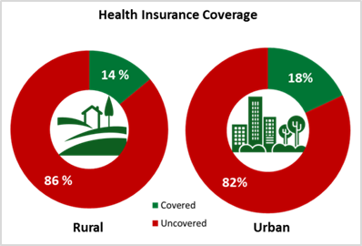

<https://en.wikipedia.org/wiki/Health_insurance_in_India#/media/File:Health_Insurance_Coverage_in_India_(Stats_from_NSSO_survey).png>

The health insurance industry in India, launched in 1986, has grown significantly due to economic liberalization and increased awareness. By 2010, over 25% of the population had access to health insurance. The General Insurance Corporation of India and the Insurance Regulatory and Development Authority (IRDAI) launched an awareness campaign to reduce procrastination and improve awareness among all population segments.

* Mediclaim vs Health Insurance:

(source: <https://www.maxlifeinsurance.com/health-insurance-plans/difference-between-mediclaim-and-health-insurance>)

A Mediclaim policy is designed to offer protection from medical expense claims. Mediclaim is a cost-effective choice that can lessen the impact of any unanticipated health emergency. However, the coverage it provides—whether in terms of hospitalization costs or the price of treatment for a particular illness—is very constrained. Any extra costs that are not covered by this policy must be paid for by you or your family.

The main advantages of medical insurance are:

Health Coverage: A Mediclaim policy operates on the principle of an insured sum that is payable for hospitalization and disease-specific treatment costs.

Simple Claim Settlement: A Mediclaim policy pays claims by providing cashless treatment and payment.

Family Coverage: You can purchase a medical insurance coverage to cover your spouse, children, and parents as well as yourself.

Tax Savings: By purchasing a Mediclaim policy, you can lower your tax obligation. According to Section 80D of the Income Tax Act, it is defined.

A health insurance policy will pay for a variety of costs the insured incurs for medical care or operations. The insurance coverage is typically offered as a direct bill settlement with the hospital or as a refund of the insured's out-of-pocket medical expenses. A health insurance plan's inclusion and exclusion clauses determine all of the benefits that are offered under it. A Mediclaim policy generally doesn't offer as much coverage as health insurance. This may be a factor in their premium's relative increase.

The following are some of the main advantages of health insurance:

Comprehensive Coverage: A health insurance policy offers full protection, including critical sickness insurance for a list of specified critical illnesses or medical conditions.

Tax advantages These advantages are equivalent to those of a medical insurance coverage. You are qualified to deduct the premium you pay for health insurance from your taxes.

If you hold a health insurance policy and do not have any claims during the previous policy period, you may be eligible for a No Claim Bonus at the time of policy renewal.

* Components of health insurance:

(Source: https://www.investopedia.com/health-insurance-premium-4773146#:~:text=A%20health%20insurance%20premium%20is%20a%20payment%20made%20to%20keep,the%20premium%20via%20payroll%20deductions.)

Premium:

Premiums are typically paid monthly when purchased on the individual market, while those with health insurance through their employer usually pay their share of the premium via payroll deductions. In addition, consumers may have to pay out-of-pocket costs including [deductibles](https://www.investopedia.com/health-insurance-deductible-4773113), copays, and coinsurance when they seek medical care.

Deductibles:An annual amount you must pay for covered care before your insurance starts paying claims.

Copays**:** A copayment is a fixed amount you have to contribute toward the cost of doctor visits, prescription drugs, and other healthcare when the service is provided. The insurance provider pays all or part of the remaining amount.

Coinsurance:A percentage of the medical bill you have to pay, even after reaching your deductible. The insurer pays the remaining portion of the bill.

Coverage limits:

The insurance company places a coverage limit on the treatment cost of certain diseases under specific treatment sub-limits. Therefore, even if your sum insured is high, due to the sub-limit clause on specific medical procedures, you will not be able to claim your entire hospitalization expenses.

In-Network and Out-of-Network Providers:

Health insurance plans often specify a network of healthcare providers with whom they have negotiated rates. Services from in-network providers are usually less expensive for the policyholder. Out-of-network providers may be covered but at a higher cost to the policyholder.

When a doctor, hospital, or other provider accepts your health insurance plan we say they are in the network. We also call them participating providers. When you go to a doctor or provider who does not take your plan, we say they are out of network.

* Who uses health insurance?

(source: https://www.bajajallianz.com/blog/health-insurance-articles/types-of-health-insurance.html)

1. Individuals and Families:

Individual Health Insurance:

Individual health insurance plans are purchased directly from insurance companies, providing coverage for self-employed, unemployed, or uninsured individuals or families.

Family Floater Health Insurance:

Family floater plans cover the entire family under a single policy. They are cost-effective and provide a single sum insured that can be shared among family members.

Group Health Insurance:

Group health insurance is provided by employers to cover their employees. It offers coverage to all employees as a group, often at a lower premium compared to individual plans.

Government Health Insurance:

The Indian government offers various healthcare schemes, including the Central Government Health Scheme (CGHS), which provides cashless medical services and access to empaneled hospitals and dispensaries. State governments also have their own health insurance schemes, such as the Rajiv Aarogyashri Community Health Insurance Scheme in Andhra Pradesh and the Mukhyamantri Amrutum Yojana in Gujarat. The Ayushman Bharat Pradhan Mantri Jan Arogya Yojana (PM-JAY) is a government-sponsored program aimed at providing healthcare coverage to economically vulnerable families, including students. State-specific health insurance programs, such as the Yuva Swavalamban Yojana in Maharashtra, also provide health and life insurance coverage for students pursuing higher education. The National Health Protection Scheme (AB-NHPM) provides financial protection to families through health insurance coverage. Some educational institutions offer optional health insurance programs for students.

Student Health Insurance:

Student health insurance plans are specifically designed for college and university students. They often provide coverage for basic healthcare needs.

1. Employer:

An Employer-Employee Insurance is a type of policy in which an employer purchases a life insurance policy and beneficiary for its employees. It means that the ownership of the policy is with the employer and the premiums are paid by the employer while the employee is the beneficiary of the policy.

This practice of group insurance policy is mostly followed by employers because it works as a tool to retain old employees, attract new employees & ensure the social security of their employees.

Statistics Associated with Health Insurance Coverage:

In India, there were about 514 million people with health insurance plans in 2021, which only accounts for 37% of the population.

In India, there are around 400 million people without any type of health insurance. According to estimates, 70% of the populace has either voluntary private health insurance or public health insurance. Over 40 crore people, or the remaining 30% of the population, do not have health insurance.

Statistics Concerning Health Insurance Premiums:

In 2021, the Indian health insurance market's gross written premium was estimated to be worth around INR 637 billion.

A total of INR 272 billion in insurance premiums were collected by public sector health insurers, INR 159 billion by private sector health insurers, and INR 151 billion by independent health insurers in India.

Maharashtra had the largest percentage of health insurance premiums in all of India in 2021. The south-western state contributed for about INR 183 billion in health insurance premiums, or 32% of all premiums. Karnataka and Tamil Nadu came in at 10% that year.

Cost-Related Statistics for Health Insurance:

According to the Economic Survey 2022–2023, the budgeted expenditure on healthcare by the Indian government was about 2.1% of GDP in FY23 and 2.2% in FY22, compared to 1.6% in FY21.

According to the same poll, the percentage of spending on healthcare services climbed from 21% in FY19 to 26% in FY23.

In India, out-of-pocket expenses accounted for roughly 48% of all healthcare spending in the 2019 fiscal year. This number is significantly lower than the 64.2 observed in FY14.

Health-related social security costs rise from 6% in FY14 to 9.6% in FY19.

(source: https://www.forbes.com/advisor/in/health-insurance/health-insurance-statistics/#:~:text=Around%2070%25%20of%20the%20population,individuals%2C%20devoid%20of%20health%20insurance.)

* Prescribers of health insurance:

Health insurance plans are provided in India by a large number of private insurance firms. Private health insurance companies with a good reputation in India include ICICI Lombard, HDFC Ergo, Bajaj Allianz, Max Bupa, Reliance General Insurance, and many more. These organizations provide a selection of health insurance plans to suit various requirements and price ranges.

Several public sector insurance firms that provide health insurance are owned and operated by the Indian government. Popular examples include:

Life Insurance Corporation of India (LIC): LIC offers health insurance products even though its main business is life insurance.

Various health insurance plans are offered by the New India Assurance Company, a general insurance firm operating in the public sector.

Health insurance is provided by the National Insurance Company, another government-owned insurer.

Government Health Programs: The Indian government administers a number of health insurance programs to cover healthcare costs for various population groups. The Pradhan Mantri Jan Arogya Yojana (PM-JAY), popularly known as Ayushman Bharat, which offers health insurance coverage to economically underprivileged households, is one of the most renowned programs. Additionally, several Indian states have their own health insurance programs, such as the Aarogyasri program in Telangana and Andhra Pradesh.

Colleges and Educational Institutions: Some educational institutions in India provide their students with health insurance coverage. This is frequently a component of the educational institution's services for the welfare of its students. Medical costs for students who are injured or become ill while enrolled in school may be covered.

Limitations of health care:

(source: <https://www.adityabirlacapital.com/abc-of-money/know-advantages-and-disadvantages-of-buying-health-insurance>)

Cost and Affordability: The average Indian citizen may find private health insurance premiums to be expensive. They argue that lower income groups may find the cost of insurance to be expensive preventing those who most require it from obtaining it.

Lack of Coverage: Critics frequently point out that waiting periods, sub limits, and exclusions are common in Indian health insurance policies, which might restrict the extent of coverage. Due to these restrictions, policyholders may not be completely insured in the event of certain medical conditions or treatments.

Pre-Existing Conditions: Some health insurance plans in India feature waiting periods for pre-existing conditions, which implies that those with such conditions may not be covered right away or may only receive limited coverage.

Health insurance claims have occasionally been turned down by insurance companies. Critics contend that insurance firms may occasionally use gaps or ambiguities in policy language to reject valid claims, which may disappoint policyholders.

Lack of Transparency: Some opponents claim that Indian health insurance policies can be complicated and hard to understand. They contend that it is difficult for policyholders to understand their rights since insurance companies may not always be open about the terms and conditions of the contracts.

Profit Motive: There have been questions regarding the private insurance industry's focus on profit. Opponents argue that insurance firms may put profit ahead of policyholders' well-being, which could result in reductions in costs that lower the standard of care.

* Eligibility criteria for students in health insurance:

(source: https://www.acko.com/health-insurance/student-health-insurance/)

Student insurance plans require enrollment in a recognized educational institution, with eligibility criteria varying based on student status. Most plans are designed for young adults, covering ages 17-30. Some require citizenship or residency, and enrollment must occur during a specific period. Dependent status may also affect eligibility, and international students may need visa documentation and specific insurance coverage requirements.

Universities and insurance providers typically appoint an enrollment period for students to enroll or waive coverage, often before the start of the academic year or semester. Students can enroll online, complete paper forms, or waive coverage if they have equivalent coverage from another source. Late enrollment can result in limited coverage options or penalties. Students can also change or update coverage during life events like marriage or childbirth.

* Range of services for students covered by insurance and its limitations:

Primary care services include routine check-ups, management of common illnesses and injuries, emergency services, hospitalization, prescription drugs, specialist care, laboratory and diagnostic tests, mental health services, preventive care, maternal and reproductive health, and dental and vision care. Some student insurance plans may include limited coverage for these services.

Student health insurance plans may have limitations on services like doctor visits and treatments, and may exclude certain services like elective cosmetic procedures, weight loss surgeries, pre-existing conditions, and experimental treatments.

**DAIICT Health Insurance:**

All students are covered under the Group Mediclaim Insurance Policy (coverage of Rs. 50,000 per annum) and Personal Accident Insurance Policy (coverage of Rs.50,000 per annum) with Reliance General Insurance Company on payment of premiums and completion of certain procedures registration. With this medical coverage, the students can avail cashless in-patient medical treatment in various hospitals approved by the Reliance General Insurance Company.

Hospital-RGI locator: By using this link you can check whether the hospital you're getting admitted is covered under RGI(reliance general insurance)

[https://rgi-locator.appspot.com/?Search_by=hospital&sourcesystem=website&phonenumber=&emailid=#](https://rgi-locator.appspot.com/?Search_by=hospital&sourcesystem=website&phonenumber=&emailid=)

Methods to claim insurance:

After getting admitted to a hospital covered under RGI, there are 2 ways to claim your insurance:

1. Cashless(preferable) Cashless means that the insurance agency will pay the money on your behalf to the hospital and you don't have to pay the bills.

To use this method you need to follow the steps given below:-

* Print Health Card Steps to be followed to generate the health card:

1. Go to the Website given below <https://www.reliancegeneral.co.in/Insurance/Self-Help/Self-Help.aspx>

2. Go to policy center

3. Select health card

4. Enter Policy Number in the field provided (GPA in case of accident, GMC for General purpose)

GMC code for the institute: 160232228120000061

GPA code for the institute: 160232229140000061

5. Input Student ID and other required information

6. Print health card.

* Register Claim

Now after generating the card, you have to call on +91 22 48903009 (the insurance company) to inform them that you have been admitted. As soon as you register a claim, an SMS would be received from reliance Insurance providing you with the claim intimation/registration number. Store remember this number as it is very important for the processing of the insurance claim.

Note: You must have to do this process within 12 hours after getting admitted to claim the insurance. (Can also be done by any of your friends on your behalf).

1. Reimbursement (Not preferable)

In case you don’t want to go with the cashless method you can receive the money from the insurance company after you’ve paid the bills through reimbursement for which you have to fill out the following form and submit it to the agency.

Link for form:

http://intranet.daiict.ac.in/~daiict_nt01/Announcement/Medical%20Insurance_Students/Insurance%202022-23/Health-Claim%20Form200408120903_662845222.pdf

NOTE: Also, note that these insurance policies have their own set of rules and regulations for which the institute, its staff or HMC is not responsible.

There are certain rules and regulations according to which you might have to pay some amount for some facilities.

Please refer to the documents available on the intranet for rules and regulations related to the insurance: <http://intranet.daiict.ac.in/~daiict_nt01/Announcement/Medical%20Insurance_Students/Insurance%202022-23/>

* List of commonly excluded items from insurance coverage:

<http://intranet.daiict.ac.in/~daiict_nt01/Announcement/Medical%20Insurance_Students/Insurance%202022-23/ListofCommonlyExcludedItems200408120903_1126613788.pdf>

(Used DAIICT website and DAIICT medical insurance pdf)

NETWORK MAP:

Object: Healthcare consumer

Link to pdf: <https://drive.google.com/file/d/1_Am1tpSednx7NlOxxZcFWkk1yk7mZ_nr/view?usp=share_link>

TEAM:

| 202201005 | AKHIL SAMPATKUMAR RACHHADIA | (Surveys, Network map, Interview transcript, making graphs) |
| --- | --- | --- |
| 202201105 | RISHI JIGAR SHAH | (Surveys, Network map, Interview of patient, Interview transcript, conclusions and proof reading everything) |
| ,202201172 | AKHAJA DHRUVIN JAGDISHBHAI | (Surveys, Network map) |
| 202201194 | SARANG KENIL ARUNBHAI | (Surveys, Network map, Interview transcript, making graphs) |
| 202201227 | NISHANK KANSARA | (Surveys, Network map, Interview transcript) |
| 202201252 | VASAVA MARMIK DHIRENDRABHAI | (Surveys, Network map) |
| 202201269 | VARNIKA CHHAWCHARIA | (Surveys, Network map) |
| 202201291 | PATEL NAISARGI NILANGBHAI | (Surveys, Network map) |
| 202201341 | SHASHWAT MENON | (Surveys, Network map) |
| 202201407 | PATEL HERIK KIRANBHAI | (Surveys, Network map, Interview of pharmacists, detailed system/practice, Final editing) |
| 202201472 | PRAJAPATI KAUSHIK RAMESHBHAI | (Surveys, Network map analysis, Interview questions) |
| 202201485 | PATEL PRATHAM PRAVINBHAI | (Surveys, Network map, general help) |
| 202201510 | VARIYA HITANSHU JAYDIPBHAI | (Surveys, Network map analysis, Interview) |
| 202203015 | JAYANT SHARMA | (Surveys) |
| 202203027 | PATEL ADITYA MUKUNDBHAI | (Surveys, Network map, Interview of worker) |
| 202203031 | PARMAR UDAYKUMAR KANTILAL | (Surveys, Network map analysis) |